HOSTING TROLL-FREE/PLAYFUL/INTERACTIVE
VIRTUAL EVENTS WITH ZOOM
Dear Friends,
A few years ago I was hosting my very first open Zoom info-session for work. Everyone was invited! We shared the link on Twitter / Facebook / Everywhere. “It will be great!” We thought, “What can go wrong?” When the meeting began, I noticed something off was happening. Let’s just say it was akin to this.
Here is a snapshot of my reaction:
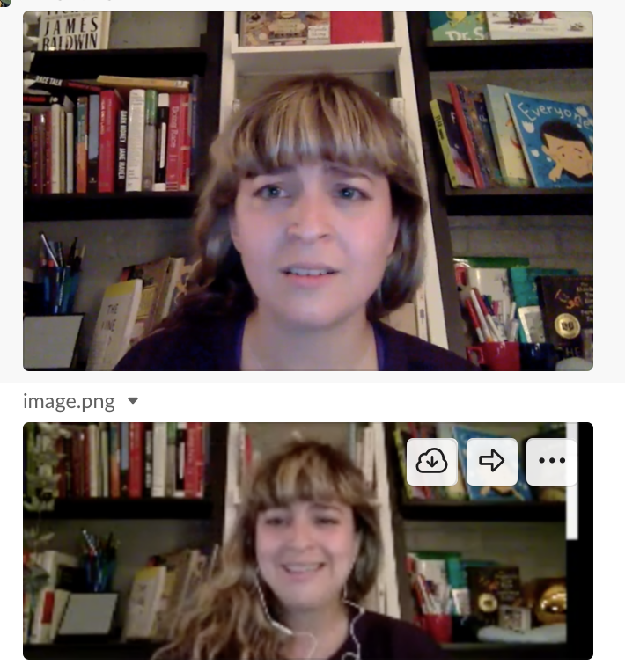

I didn’t know what to do and my colleagues didn’t have co-host powers so they couldn’t save me! I kept blocking the user while simultaneously trying to present to an audience and they kept coming back in, showing their X-rated content, and writing things on the screen (there were at least 2 trolls).
This document is intended to not only give you some tips on hosting beautiful interactive and playful online events, but also to help you set yourself up for success with the right preferences so this doesn’t happen to you!
There are lots of virtual event tools out there, like Google Hangouts, YouTube Live, Vimeo Live. For this guide I’ll delve into how to use Zoom specifically. However, a lot of the best practices explored here are broadly applicable to other tools. My goal is that reading this document will give you all the tools you need to be able to set up a meeting and host it on Zoom (or other platforms) in fun and interactive ways.
This is an unparalleled and out-of-time moment in which we have an opportunity to come together and bring our gifts to the world in a digital manner. There are no shoulds implied in this document. This is only for people for whom hosting virtual events gives you energy. If not, no need! I know that this is a difficult time and that switching from in-person to online meetups is hard. I hope that this will ease the process and answer some of your questions. If you’re nervous about hosting and want to get a glimpse of other events, check out our CreativeMornings Virtual FieldTrips and Virtual Events!!
If you have follow up questions, don’t hesitate to reach out! Also, this doc, as everything I do, is iterative. It will change. There will be typos. Thx for understanding. ❤️
DOCUMENT CONTRIBUTORS
I am so grateful to CreativeMornings (Julie for the edits!!), CreativeMornings/Austin (shout out to Marty Robbins for the A/V setup), and CreativeMornings/Denver, for piloting the first-ever virtual CreativeMornings events, and for their incredible contributions to this document. Their work inspired me to compile and illustrate this guide for the CreativeMornings community and beyond, in hopes that everyone can host beautiful events like theirs. I would also like to shout out the Scratch Educator Meetups crew and T550 (Hi Karen Brennan/Laura Peters/Wilhelmina Peragine) for teaching me everything I know about pedagogy, hosting virtual events, and creative learning. And to Grrz for reading this doc and editing it. And for being in my Zoom GIFs. Love y’all.
Much love,
AK
Table of Contents
Section 1. Before the Event
Step 1. Book Your Event Space
Create or Update Your Zoom Account
Schedule Your Zoom Call

Step 2. Send Announcement, Registration, & Emails
Send your Event Announcement & Registration Info
Send A Reminder Email!
Step 3. Virtual Event Setup
Zoom Preferences (Software) *most important*
Video Setup (Hardware)
- Lean Tech | High Tech
Video / Audio Setup (Atmosphere & Lighting)
Learn Zoom Features
- Exploring Display Options | Sharing Slides, Videos, & Music | Spotlighting a Speaker | Breakout Groups
Step 4. Pre Event Setup
Section 2. Event Play-by-Play — In Three Parts
PART 1. Opening & Introduction
Open the Doors
Welcome the Participants + Introduce Zoom Features

PART 2. Music & Participant Interaction
Feature Local Music and/or Speakers & Performers!
Hold a Q&A
Bring People Together with Breakout Rooms

PART 3. Closing the Event
Closing Comments & Group Photos
Ending the Meeting

FIVE RULES FOR HOSTING VIRTUAL EVENTS
1) HAVE A CO-HOST: Have at least 1 Co-Host on your call to help troubleshoot.
2) BE KIND TO YOURSELF: Things will go wrong (maybe). It’s ok! Have patience, experiment, relax.
3) DO AT LEAST ONE PRACTICE RUN: Get friends or family or anyone to join you in a practice round. You don’t know what you don’t know until you bump into a question. Troubleshooting is ESSENTIAL.
4) YOU GOT THIS: Just try it. It’s fun!
5) DO NOT SHARE YOUR LINK ON SOCIAL MEDIA: You will get zoombombed. Its awful.

Section 1. Before the Event

Step 1. Book Your Event Space

Create or Update your Zoom Account
Go Zoom Pricing Page — https://zoom.us/pricing
- When Zoom says “# of Hosts” it does not mean Co-Hosts. The “Add Host” option actually means that you can host multiple meetings simultaneously. Most of you will not need this feature! You can use the co-host feature and with only one “host” on thee account. Unless you are hosting multiple synchronous meetings, you don’t have to pay for extra hosts.
- A free zoom account will allow you to host up to 100 participants for up to a 40-minute call. This is a great option for anyone who doesn’t need an hour for your event!
- For larger events A Pro account will work perfectly.
  - You can add on 300-1000 attendees this way through paid upgrade packages.
  - You can have up to 24 hours of meeting time (but who wants to meet for 24 hours?)

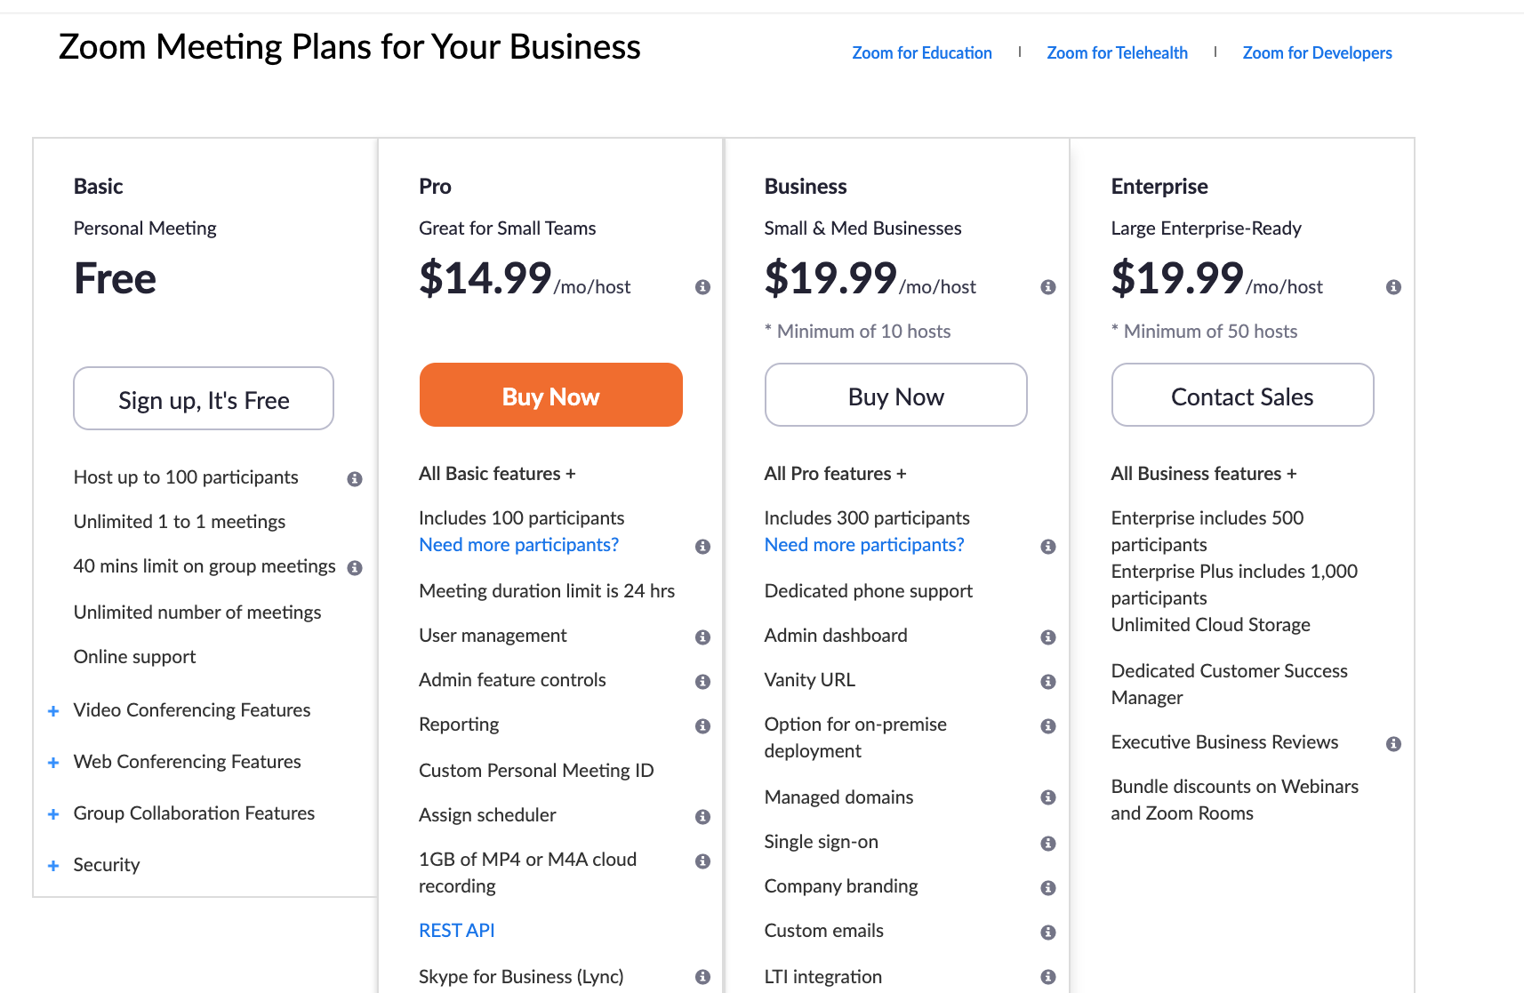

Schedule your Zoom Call
Watch this 1-minute Zoom video to learn how to schedule your first Zoom Meeting:
How to schedule meetings. If you are not sure which Zoom package to get, learn more under Zoom Pricing. I recommend making your event password protected.

Step 2. Send Event Announcement, Registration, & Reminders

Send Your Event Announcement & “Register” Attendees
There are many ways to announce your event and register attendees! You could use a platform like Eventbrite or Meetup, or keep track of everything yourself.
Zumba instructor extraordinaire @LauraPeters used a google form as a simple way to get a list of friends who would participate in her Zumba class, and also let her participants know what the rules and regulations were. Notice (below) that she did not share her zoom link on social media. This method ensured that only people she emailed directly (those who signed up) would be able to have access to her Zoom Link. While this is not the only way to avoid having spammers, it is certainly a great way!
You could also create a private, invite only facebook group and share the Zoom link there, allowing only friends-of-friends to be invited and to join.

EVENT ANNOUNCEMENT SOCIAL MEDIA SAMPLE
I'm hosting my first "ZOOMba" class tonight at 6pm EDT! RSVP: bit.ly/zoombawithLKP

EVENT ANNOUNCEMENT SOCIAL MEDIA SAMPLE
RSVP for my virtual "ZOOMba" class!
When: Thursdays, 6pm
Where: From your house!
How: Download Zoom and RSVP here to get the private link to join! https://forms.gle/ni9LhPTXE93bZfT46

EVENT ANNOUNCEMENT EMAIL SAMPLE
Hi Friends!

I’m hosting a [insert your topic] workshop over Zoom on Insert Date and Time.
I have never hosted anything on Zoom before, so this will be an experiment! We’ll run with it!
If you’re interested in joining me, fill out this google form and I will send you a link to the event!

Much love,
(Your name)

Send A Reminder Email!
Whether you have chosen to include your link in your initial posts / emails or event announcements, it is always important to send a reminder email to give people the link again in case they lost it! This is also a great time to follow up with any other important information that you need to share. Below is another wonderful email from LP about her ZOOMba class.

EVENT REMINDER (24 HOURS IN ADVANCE) EMAIL EXAMPLE
Intro Note: Hi friends! I'm so excited to try out our first online Zumba class! Below are a few details that will help you get ready for class!
What Should I Bring to Class?
For the class, you'll want to wear comfortable clothes to move around in, and sneakers or bare feet (depending on the flooring situation in your house). Have water on hand!

Are You Accepting Donations?
This class is free, but if you feel like making a donation, you can Venmo me @laurakpeters. Proceeds will go to local food service workers who have been laid off due to the restaurant closures in effect.
How Do I Use Zoom?
If you haven’t used Zoom before, check out this link to learn how to join the call. I recommend viewing the class from a laptop, but a tablet or phone will also work.

MEETING DETAILS
Topic: Zoom-ba with LKP!
Time: Mar 19, 2020 6:00PM Eastern Time (US and Canada)
Join Zoom meeting: [link goes here]

Much Love,
LKP

Step 3. Virtual Event Setup

Zoom Preferences (Software)
When you’re hosting a Zoom call, it’s really important that you and your co-hosts feel like you have control over the space. Here are some recommended settings to help get your meeting off to a good start (and help you avoid ZoomBombing)…

Go to Settings (Meeting) — https://zoom.us/profile/setting?tab=meeting
Under Schedule Meeting
- Participant video (Off): Sometimes people are surprised when they enter the chat and are seen in their PJs! Make sure to give people the option to be on camera. You can make an announcement about this when the call starts if some folks don't realize they can turn their video on. Simply say, “We’d love for you to join us by turning your cameras ON!” (We’ll share more about this in Opening & Introductions.
- Join before Host (Off): Make sure that you are the first one in the room so that you can welcome everyone.
- Only authenticated users can join meetings (Personal Preference): This is a useful way to make sure that only CM attendees come to your meeting. When a link is open and there is no barrier to entry, anyone can join. This can invite trolls and cause disruption (you'd be surprised...it can happen!) Just make sure you’re confident with how to set this up!
- Mute participants upon entry (On): This ensures that there is not a ton of noise when the event starts. The host can control when participants can un-mute. — NOTE: It is also helpful, once you’re in the meeting, go to the ‘participants panel’, click more and UNCheck ‘Allow participants to unmute themselves.’
Under In Meeting (Basic)
- Chat (On): This allows participants to chat and say hi to one another during the event and through the talk. It's a nice way for people to connect through the event. We’ll share some tips on how to use this in Section 2.
- Play sound when participants join or leave (Off): If you have an event of over 15 people, this could get a little much.
- File transfer (Off): Given that you’ll be sharing an open link, you don’t want anyone sending any explicit content or viruses through file transfer!
- Co-host (On): It is important to add a few of your organizers as co-hosts on Zoom so that you can have solid control over the virtual space. It can be difficult to do this with only one person. Once you have this setting on, to make a co-host, click “participants” on the Zoom control panel, and then in the pop-up box, hover over a person’s name in and click “make co-host”. Learn more about enabling and adding a co-host in Zoom’s FAQ.
- Polling (On): Add “Polls” to the meeting controls. This allows the host to survey the attendees.
- Allow host to put attendee on hold (On): If you have a disruptive attendee, this feature is very useful. It allows hosts to temporarily remove an attendee from the meeting.
- Always show meeting control toolbar (On): If you're unfamiliar with Zoom it can be helpful to have your meeting controls visible at all times.
- Screen sharing (All Participants) (Off): If you have a speaker who is sharing slides, or you want your community to be able to share their screens, it is good to keep this on. However, if only you and your Zoom co-hosts will be sharing your screen, we recommend keeping it off so as not to have any disturbances. If you are sharing an open link (you don’t know everyone who is attending, keep this OFF.
- Annotation (Off): This allows participants to use annotation tools to add information to shared screens. This can be very distracting, since this allows people to draw all over the presentation for everyone to see.
- Whiteboard (Off): Allowing participants to share whiteboard during a meeting can get tricky and busy.
- Allow removed participants to rejoin (Off): Again, if you have a troll, they may try to come back over and over. Ensuring that removed participants cannot rejoin is a helpful way to make sure you don't have to deal with this issue!
Under In Meeting (Advanced)
- Breakout rooms (Personal Preference): Breakout rooms can be a fun way to get participants to chat with one another in small groups. You may want to have an icebreaker question and breakout groups of no more than 6 participants each. These can be nice ways to say hello, but should be held for no longer than 10 minutes each. Learn more about Bring People Together with Breakout Rooms.
- Waiting room (On): Given the number of participants you'll have, you don't want to have to let every single one of them into your event. I recommend having the waiting room On and then disabeling it once you’re ready for the event to start. This way you don’t have to worry about letting people in throughout the event. You can disable the waiting room by going to the participant panel — more — deselect enable waiting room.This can also be tricky if someone arrives late— it is easy to miss them and they’ll be stuck in the waiting room! It basically makes it easier for you as the host.
Go to Settings (Recording) — https://zoom.us/profile/setting?tab=recording
Under Automatic Recording
- Record meetings automatically as they start (On): With everything that’s going on, you may forget to record your event! Make it easy for yourself by keeping it automatic. To make sure you’re recording while the session is happening, just look for the red dot in the left hand corner of your Zoom application.

Video Setup (Hardware)
When it comes to hosting an event on Zoom, you can take many approaches to delivering a high-quality experience. Here, we’ll highlight two ways you might record your event: Lean Tech and High Tech.

1) Lean Tech: Use your Computer!
At its most simple, you can simply use your computer camera as though you were on any other Zoom call. This applies to everyone on the call—all hosts, co-hosts, musicians, and speakers.
- If you are using "Lean Tech" make sure you are connected to a land-line or ethernet internet connection for the sake of stability and dependability.
- When using your computer as the vehicle for your video recording, you’ll want to make sure to follow best practices for finding a great hosting atmosphere, and that your audio is clear and uninterrupted.
- Implement the “spotlight” feature to keep the screen on your speaker or musician while they present.
- When it comes to sharing slides, it can take a little tinkering to figure out how to best use Zoom with a different program. If you are using Google Slides, for example, make sure to share only the particular window of your slides (see how to share slides and videos).
- Turn your computer on “do not disturb” mode, and turn off notifications so nothing disturbs your screensharing.
- Practice, practice, practice! For tips on testing your video, read Zoom’s quick tutorial on how to test your audio.

2) High Tech: Use External Equipment
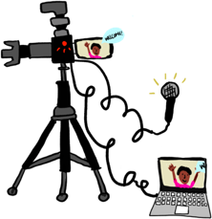
CreativeMornings/Austin has graciously outlined the hard work that they put into using high-tech recording and audio equipment to run their first live event. You can find their setup checklist here:
- Watch a recording of the CMATX A/V set-up walkthrough
- Watch a complete recording of the CMATX virtual event

Computer 1: MacBook Pro
4 port USB hub (for help connecting a bunch of these things) which connected:
- 2 Elgato Cam Links (for connecting external cameras, a video & audio input sources over HDMI)
- Presenter clicker/remote
- Gigabit ethernet connection (we used a USB 3.0 adapter)

HDMI video cable, connected to a LED monitor (Mirrored display)

Stereo headphone splitter, connecting to:
- Headphones for the director
- Small speaker for the room to hear Zoom participants who are unmuted

USB cable connected to our soundboard (This was a USB-A to USB-B cable, like most printers use)

…and it was connected to AC power.

Computer 2: MacBook
USB-C hub connected to:
- Gigabit ethernet connection
- HDMI out to LED Monitor (Mirrored display)
…and it was connected to AC power.

Sound board: Presonus SLMAR12 12Ch Hybrid Digital/Analog Mixer
Chosen because it could allow for a USB output of audio, and had multiple XLR inputs for:
- Emcee/host microphone
- Presenter lav mic
- Room mic, for atmosphere (clapping and feeling like you were there)
- Musician’s feed

Multiple Cameras
Two (2) Canon DSLRs (we don’t know anything more about them than that, but…)
- Each had an HDMI output that was a real-time feed
- Some DSLRs have this but require mini-HDMI, and some have settings that show the camera’s settings too, like white balance, running clock, etc. (So, you many need to learn your camera’s settings well enough to turn these off, or potentially borrow a different camera.)

iPhone 11 Pro
- Used as a roaming camera
- Joined as a Zoom user, and switched input to rear-facing camera
- Director would choose that user as “Spotlight Video” when we wanted this video featured

Audio and Video Setup: Atmosphere and Lighting (For High and Lean Tech)
Whether you choose to go High-Tech or Lean-Tech, being mindful of your video background is very important! As you test out Zoom with your fellow organizers, take note of what you see in the background of each window. Is it hard to see a participant because of too much or too little light? Is the background extremely busy or extremely bland? Here are a few tips for choosing the right spot to record.
Video Backgrounds Best Practices
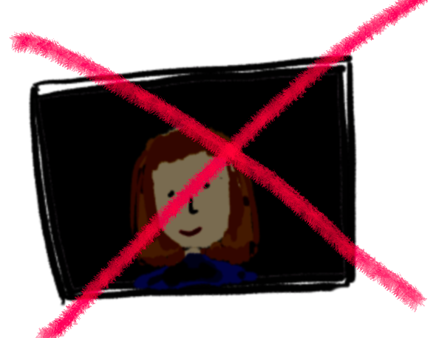  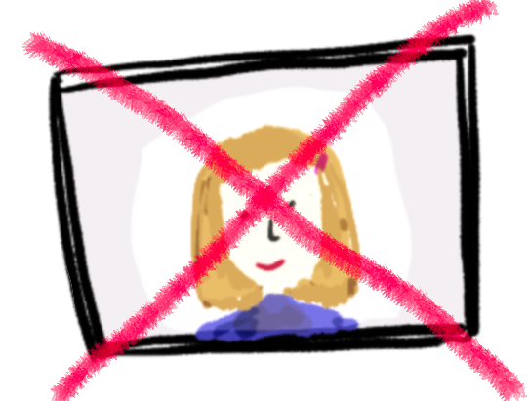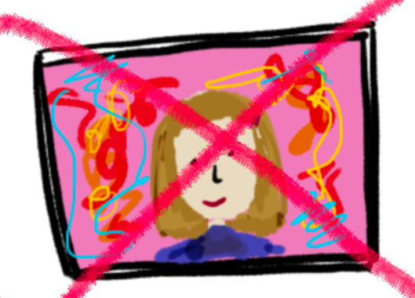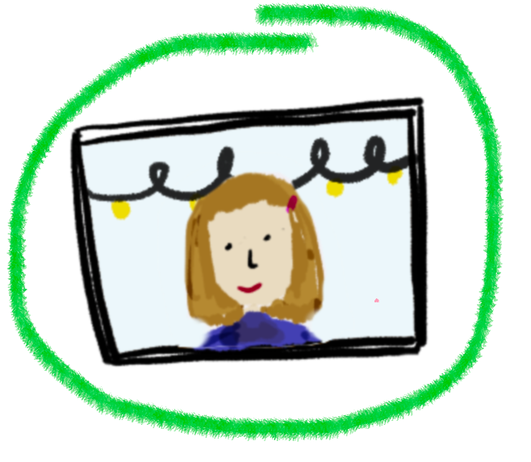 | - Be front-lit, not backlit! A background that is too dark can swallow your face. However, if you are sitting directly in front of a bright light (backlit) your screen will go dark! Make sure to have enough light that your face is visible to the participants. You can use lamps, consistent natural lighting, or overhead lights to keep things steady.  - On the other hand, be mindful of whether your face is being over-saturated by light. If you are using a lamp, don’t place it so close to your face that you are “burned” in the view.  - Try to keep your background simple and light, but not so simple that you look like you're in an empty conference room!  - If your background is overly busy, try to make it a bit calmer. Notice: are there people walking around behind you? Are you in a crowded space (hopefully not)?  Keep it simple, but beautiful. Have some lights or pretty signs taped up behind you, and make sure your space feels good to you!

Audio Background Best Practices
If you are using your computer for audio and video, make sure that your camera and mic are both working while you practice your event run-through. Go to a quiet space so that background noises are less frequent. For example, if you host your event in your kitchen and your family is making breakfast, it could be disruptive sound-wise for the participants, making it hard to hear you, the host, as you present. You also want to make sure that while your host or speaker is talking, your entire audience is muted. Here’s Zoom’s brief tutorial on how to mute and unmute all.

Learn Zoom Features

Exploring Display Options
Get comfortable with the different viewing experiences! (Words remixed from Zoom.com)
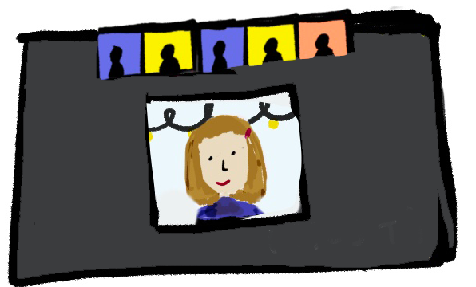  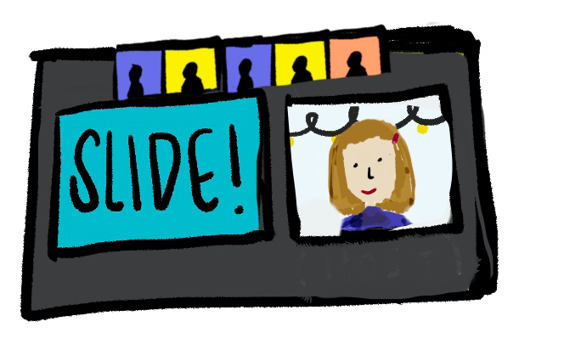 | Speaker View displays a large view of the person currently speaking, with a smaller thumbnail of the previous speaker as a picture-within-picture. During screen sharing, the shared screen is in the large display and the thumbnail shows the person who is sharing. You can toggle the slide screen back and forth to make the speaker larger or smaller (see GIF below).
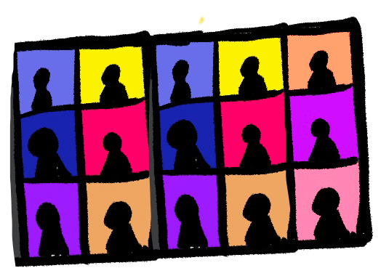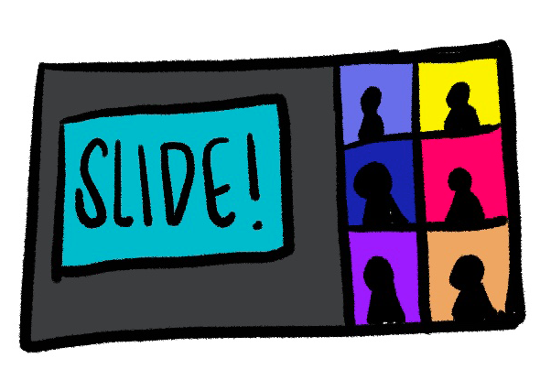 | Gallery View displays up to 25 participants on each screen, with the active speaker highlighted. If someone is screen sharing, you use the gallery feature to see participant’s responses to slides. For meetings with more than 25 participants, an arrow displays beneath to the thumbnails. Tap the down arrow to display the next group of participants on the screen, and tap the up arrow to display the previous set.
HOW DO I ADJUST MY SCREEN VIEW?
__________
DOES THE SCREENSHARE HAVE TO BE SO BIG? NO!

Sharing Slides, Videos, and Music
Sharing your introduction slides for Local Partners, Global Partners, and more, is easy in Zoom!
- Turn your computer on “do not disturb” mode, and turn off notifications so nothing disturbs your screen sharing. Make sure there is no personal information open on your computer.
- Open your slide deck or video.
- Toggle back to Zoom and click “Share” on your control panel.
- Chose the specific screen that you’d like to highlight (see GIF).
- Check “Share Computer Sound” — this ensures that any music or sound will project from the file itself, rather than from your own computer (which can get choppy).
- Click “Share.”
- Make that screen full-screen. Have a co-host on hand to make sure the participants are seeing what you’d like them to see.
Zoom Resources:
- Sharing your screen
- Screen Share A Keynote Presentation
- Screen Sharing a PowerPoint Presentation
- Optimizing a Shared Video Clip in Full Screen
- Switching Windows During Screen Sharing

HOW DO I SHARE A PRESENTATION OR VIDEO?

(Scroll down for Audio Only!)

HOW DO I PLAY MUSIC ONLY?

Spotlighting a Speaker
As you may have noticed, when you’re in “Speaker View” if many people are chatting at once, the “main video” (the large one on the screen or the one with the yellow rim around it) can jump around from person to person. When you have a speaker, or if you want you, as the host, to be highlighted, use the “Spotlight Video” feature.
More Zoom Resources:
- Spotlight Video
- Pin VS Spotlight Video
HOW DO I SPOTLIGHT A VIDEO?

Step 4. Pre-Event Setup

Pre-event Checklist (adapted from CreativeMorning/Austin)
- Send out an email to attendees with the link and brief instructions on how to download Zoom on their at home devices.
- Check and confirm Zoom Settings are good to go
- Send Zoom link to participants
- Set up computers and connect to internet (with ethernet)
- Make sure all mics are muted upon entry. You’ll get a lot of unnecessary sound otherwise. When you “mute all,” the Host or Co-host must then manually “unmute” the speaker again.
- Host assigns Co-Host capabilities to team.
- “Rename” each co-host to reflect that you are on the hosting team
  - Alexa (CMNYC)

High-Tech Setup
  - Get video cameras in place and connect to computer
  - Setup audio board and connect to computer
  - Confidence monitors are set up
  - Set up and check n-room audio
  - Make sure both computers have the slideshow in Keynote
  - Check that the clicker is working and that there’s an extra battery ready to go
- Check that iPhone is logged in and set to share video

Lean-Tech Setup
  - Practice slide sharing computer audio

Host Roles and Responsibilities (adapted from CreativeMorning/Austin)
Whether you choose to do a High-Tech or Lean-Tech event, I recommend having at least one extra person on board to support running the show. Here are some helpful roles and tasks laid out by the CreativeMornings/Austin team! If you are a solo-act, you can always bring on a friend to act as a co-host and take some of these responsibilities on!

Director:  Event Host | - Use computer that shows the host view of Zoom  - Share Keynote application, fullscreen with slides  - Troubleshoot when slides don’t advance (click on Keynote slides to bring them to “front”)  - Set speaker views as “Spotlight video,” as necessary  - Send participants to break out rooms; send heads-up note to all rooms; bring them back when ready  - Make all organizers “Co- Host” —Learn more about enabling and adding a co-host in Zoom’s FAQ.
Co-Director: Participant Moderator | - Monitor participant view  - Watch for raised hands  - Muteunmute people for Q&A  - Set speaking users as “Spotlight video”  - Communicate any user-reported streaming issues to team  - Scroll through the gallery view and ask people to turn on their video
Chat Moderator | - Monitor chat view  - Post links in chat when appropriate for partners, musician, etc.  - Ask questions to participants in the chat  - Respond to any chat questions
Troll Patrol | - Watch for any inappropriate activity in the chat and or on screen  - Block viewers if needed  - Communicate with the team if any issues are observed.
Videographer & Tech Support | - (For Hi-Tech Recording) Crucial for rehearsal and during the event  - Connect and troubleshoot the mics  - Connect and troubleshoot camera angles  - Real-time volume and camera troubleshooting  - Bring extra dongles, hubs, all video/audio equipment

Section 2. Event Play-by-Play — In Three Parts.

@KarenBrennan and @Tfivefifty taught me that every great event is run in 3 parts.
Here is a step-by-step outline of how you might want to run your virtual show on event day. I’ve included various options for interactive activities inspired by CreativeMornings chapters that you can pick and choose from if you’d like.

As you plan your event, practice with friends and see how each activity feels to you. The most important thing is that you feel comfortable facilitating and running the show (this is where your co-hosts can really help, btw!).
Click on a link below to go to a specific section, or explore them all!

PART 1. Opening & Introduction

How to open a virtual event in a way that is welcoming, useful, and full of joy.

PART 2. Music, Speakers, and Participant Interaction

How to mimic some of your favorite in-person event features.

PART 3. Closing the Event
End your meeting with warmth and love. Here’s how!

PART 1. Opening & Introduction

Open the Doors
You’ve started the meeting! People are trickling in! It takes time though. What do you do while you’re waiting for the group to arrive? I have recommended in Zoom Preferences that you turn off the waiting room feature. As participants trickle in, it can be hard to know what to say or do. Here are some ways to engage participants while they wait for the event to start.

IDEA | HOW TO
Share a Welcome Slide &  Play Welcome Music  As participants trickle in, it can be hard to know how to start. Welcome your participants with some light music using the screenshare feature. I recommend simultaneously a welcome slide, while playing Spotify in the background. Once you are ready to welcome participants, don’t forget to turn off your music! Make sure not to include any copyrighted music in the final edit of the recording if you are publishing it. | - Turn your computer on “do not disturb” mode, and turn off notifications so nothing disturbs your screen sharing. Make sure there is no personal information open on your computer.  - Open your slide deck to show the a welcome slide  - Open your music player and play great tunes  - Toggle back to Zoom and click “Share” on your control panel.  - Choose the specific screen that you’d like to highlight (the welcome slide, in this case) \ Alternatively, if you only want to share music, simply click the “advanced” tab to the right, and select the option that says “share computer audio”.  - Select “Share Computer Sound.” This ensures that any music or sound will project from the file itself, rather than from your own computer (which can get choppy).  - Click “Share!
Chat Box Introductions  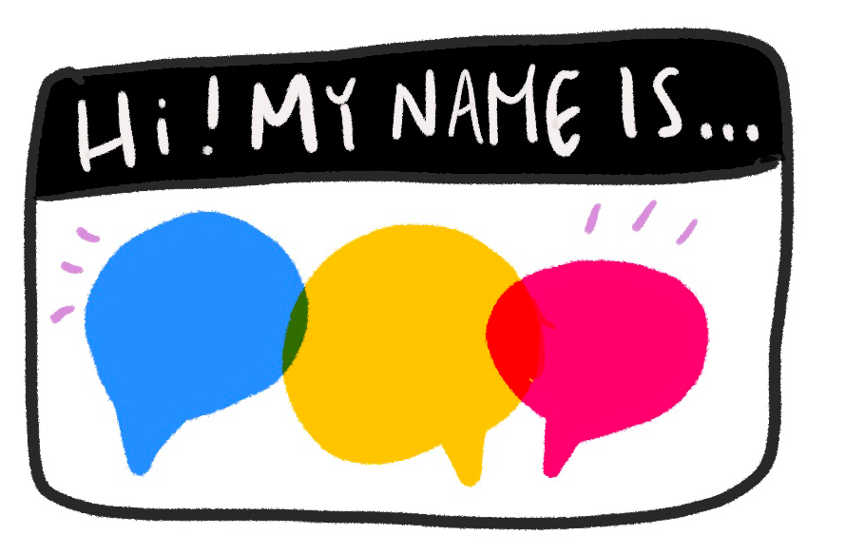  The chat functionality is a great way for the host or the speaker to pose questions verbally, and then have everyone chime in with their response. This can be used as a ‘welcome & waiting feature’ or at a different time in the call. | For example, here’s what CreativeMornings/Denver recommends:  When people are logging on and joining, ask them to drop a comment in and tell everyone where they are located. You could also give folks a prompt, such as a "Share one creative thing you are working on right now" or "What are you most grateful for today?".

Welcome the Participants + Introduce Zoom Features
Once the bulk of your attendees have arrived (perhaps 5-7 minutes after the stated ‘start’ time), let them know that the event is beginning! To start your event, walk the audience through a few things they can do in Zoom to be active and engaged audience members. This is a friendly way to help participants feel comfortable with a new platform and to ensure that everyone can participate in the experience. We recommend that you also encourage participants to use these features throughout the call.
IDEA | HOST INSTRUCTIONS | PARTICIPANT INSTRUCTIONS
FOLLOW ME!  Encourage participants to share their social handles by changing their usernames. | - Instruct participants to rename themselves by adding their social media handle to the end of their name  - Encourage participants to take a screenshot and follow anyone they are excited about! | - Click Participants.  - Hover over your name and find “rename.”  - Add your Instagram or Twitter handle to your name.  - For example, change Alexa K to Alexa (@kutlera).

HOW CAN I RENAME MYSELF?

(IT’S THE SAME PROCESS FOR PARTICIPANTS)
 | [Keep Scrolling!]
IDEA | HOST INSTRUCTIONS | PARTICIPANT INSTRUCTIONS
RAISE YOUR HAND IF...  Every month at CM/NYC, our host Tina asks the audience to “Stand Up If”. You can remix this to be “Raise your hand if”. This is a great way to teach people how to raise their hands if you’re using this for a Q&A Feature. | Note that hosts cannot raise hands, and therefore you might not see the option in your own Zoom control center.  - Add prompts to your slide deck that begin with “raise your hand if.”  - Present your slides and tell participants to “raise hands” both physically and using the Zoom feature. You can also use the polling feature on Zoom to run this experience. | - Click on Participants.  - At the bottom of the panel, you will see a blue hand. You can click or unclick it to raise and drop your hand.  Prompt Suggestions  Raise your hand if you are calling in from (your city).  Raise your hand if you are calling in from a different state.  Raise your hand if you feel grateful for someone or something.  Raise your hand if you are feeling scared.  Raise your hand if you are feeling hopeful.
HOW CAN PARTICIPANTS RAISE THEIR HANDS?
 | [Keep Scrolling!]
IDEA | HOST INSTRUCTIONS | PARTICIPANT INSTRUCTIONS
TOUR YOUR SPACE | Use a touring camera (phone or SLR) to give the audience a tour of the space you are in, especially if it’s a local business or special location.  For participants who are new to Zoom, it can be hard to navigate the screen view. If you give a quick tour of your space, or something special around you, and have your co-host share some instructions on view settings, it will give participants an opportunity to explore how to shift their screen between gallery view and speaker view. | Have your co-host say...  For those of you who have never used Zoom before, you should know that you have the ability to shift your screen throughout our talk! If you want to see everyone’s beautiful face, go to the top right corner of your screen and click “gallery view”. If you only see “speaker view” it means you’re already there! For those who see “speaker view” at the top right, click that to see only the speaker and a few faces.
20-SECOND DANCE PARTY  (Thank you CM/RVA!) | For participants who are new to Zoom, it can be hard to navigate the screen view at any time. If you host a 20-second dance party, it will give many participants a chance to move their bodies, and others an opportunity to explore how to shift their screen between gallery view and speaker view.  Get extra tech savvy and teach them how they can change their screen during a screenshare also! | For those of you who have never used Zoom before, you should know that you have the ability to shift your screen throughout our talk! If you want to see everyone’s beautiful face, go to the top right corner of your screen and click “gallery view”. If you only see “speaker view” it means you’re already there! For those who see “speaker view” at the top right, click that to see only the speaker and a few faces.
HOW DO I ADJUST MY SCREEN VIEW?
__________
HOW DO I ADJUST MY SCREEN VIEW DURING A SCREENSHARE?

PART 2. Music, Speakers, and Participant Interaction
Here are more great ways to make your event interactive, engaging, and warm.

Feature Local Music and/or Speakers & Performers!
If you are a musician or performer, or you’re hosting one, follow CreativeMornings/Austin’s lead. They did a great job of featuring their musician and the participants loved it.

Introduce the Performer
- Share an information slide (thank you CreativeMornings/Austin!): This slide has information about you or the performer / speakers’ website, social media info, and venmo for donations. Make sure to call attention to this in the chat box as well, so participants can easily access the information from multiple points of reference!
- You can share this screen for the duration of their performance if they don’t have slides to share, or show it before and after and tell participants they can screenshot it if they’d like!
- This is also a great opportunity to ask for venmo requests for either the performer OR a local support initiative that you’re giving donations to (thank you for that idea @laurapeters)!

SAMPLE SLIDE: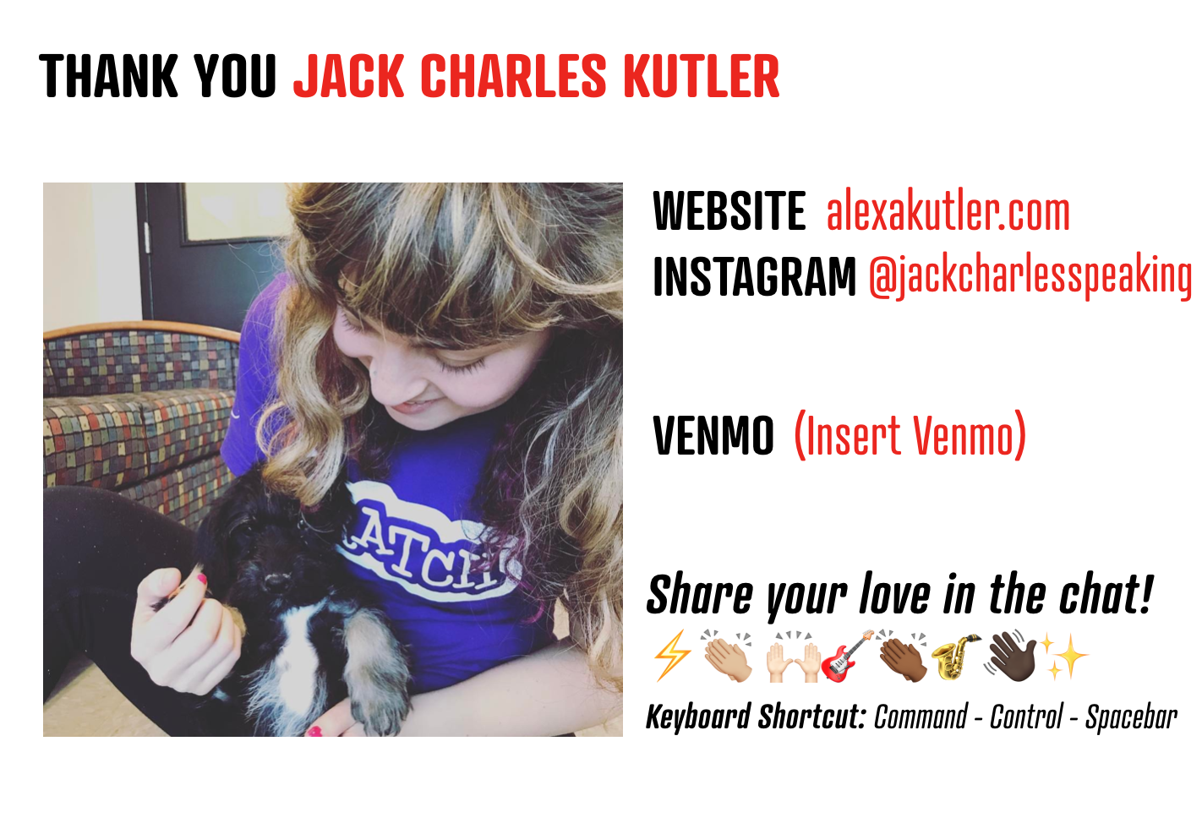

Spotlighting a Speaker / Performer
When you have a speaker, or if you want you, as the host, to be highlighted, use the “Spotlight Video” feature. This will make your speaker the main view on the screen. This is great for anyone hosting a speaker or a performer.
More Zoom Resources:
- Spotlight Video
- Pin VS Spotlight Video
HOW DO I SPOTLIGHT A VIDEO?

Participant Engagement Ideas
If you’re hosting a speaker or talk, the in-person experience doesn’t always convert when it comes to video. It can be helpful to include some of these fun things for participants to do!:

- Sing along? Sing alongs are GREAT! HOWEVER, on Zoom, I recommend that you keep all participants muted. The platform doesn’t translate well to 100 people singing at once. Have your song-leader be heard by all, and have each person sing along in their own homes with them, but don’t let anyone unmute themselves or it can get cacophonous, sadly!!
- Take a picture of yourself with the performer: Get into “speaker mode” and take a screenshot of yourself smiling with the speaker.
- Use the chat box to give snaps and claps: Use text to respond to things that you enjoy about what the speaker is saying. Participants can use emojis (control+space+command) 🙌 👏, or write in words of affirmation.
- Encourage participants to be expressive: Ask them to show the speaker that they are responding to their talk by keeping their videos on while during the talk. Let them know they can smile, wave, laugh, cry, give jazz hands — It makes a difference!
- DIY Signs: Make fun signs [links to twitter] to hold up as “reactions” during your meetings!

Hold a Q&A
- If you’d like, encourage participants to ask questions using the chat box. (Note to chat moderators: this is your time to shine and reflect questions back to the speaker!)
- Participants can also use the hand raise feature and the moderator can call on them and unmute them.

Bring People Together with Breakout Rooms

Breakout rooms create the opportunity for beautiful participant interaction. Think of them as “small tables” where participants can get to know one another on a more personal level. When you have groups of over 10 people, not everyone will be heard. Breakout rooms create the potential for everyone to feel connected at your event.

Here are best practices for initiating breakout rooms.

Note: You must be signed in as a host or co-host to initiate Breakout Rooms.

Explain the Activity
Let participants know that you’re going to try something new. Share a question or prompt on your slide deck and read it to participants. Let them know that they will be sent into different breakout groups to discuss this.

For Example: “Once you get into your breakout room, introduce yourself by sharing your name, where you’re coming from, and your personal super power. Then, share one thing that you’ve looked to for hope during this time of isolation and transition.”

Create your Breakout Rooms
- Make sure you have breakout rooms enabled in your preferences. [See: Zoom Preferences ]
- Click Breakout Rooms on your Zoom Control Panel. [See GIF Below]
- A window will pop up. Choose how many rooms you want to create. Zoom will show you based on the number of participants in the room, how many people will be divided into your rooms.
- Click “Automatically” to let Zoom randomly place people in the rooms. You could also do it manually if you have a small group.
- Click “Create Breakout Rooms”
- Go to Advanced > Options and
  - Adjust how long your Breakout Rooms will be open for. This will create a timer in the top right-hand corner of everyone’s screen so people can know how much longer they have in their groups.
  - Check the box that asks you if you’d like to put participants in breakout rooms automatically. This means that they won’t have to click anything to be sent to their Breakout Room.
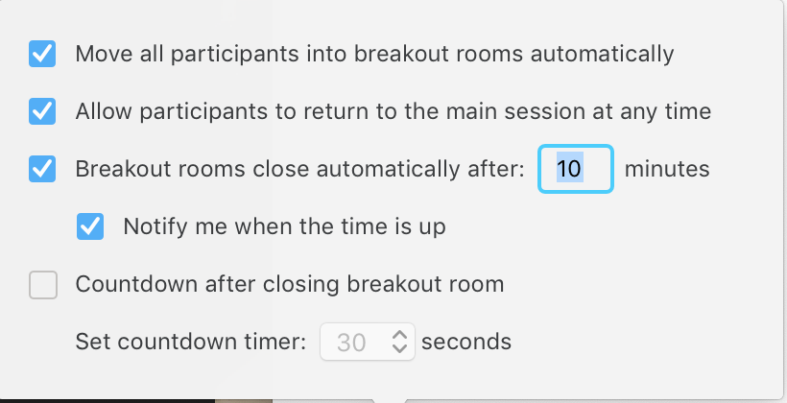

- Let Participants Know they are about to be sent in their Breakout Rooms.
Remind participants how long they will be in the room, and to be mindful of sharing space with one another. Also let them know that if they need assistance, click “ask for help” and it will ping the host. It will also send the host into their room. Let them know that their screens may go blank in a moment...
- Click “Open All Rooms” and send everyone off!
- Note: Any late-comers will not be sent to breakout rooms automatically. Make sure to have a co-host (or yourself ) in the main room to keep them company.
- Watch this Zoom tutorial for more information about how to create a breakout room.

HOW DO I CREATE BREAKOUT ROOMS?

Interact with the Breakout Rooms
As the host, you will not be placed into a room, however, there are many ways to engage participants as the host in the breakout rooms.
- Broadcast a message to all breakout rooms: In the GIF below, you’ll see me writing, or “broadcasting” a message to all of the rooms. It’s helpful to remind participants of the prompt after you send them to their breakout rooms, and then to also give them a heads up that they’ll be returning to the main room about 1 minute before it’s time to go.
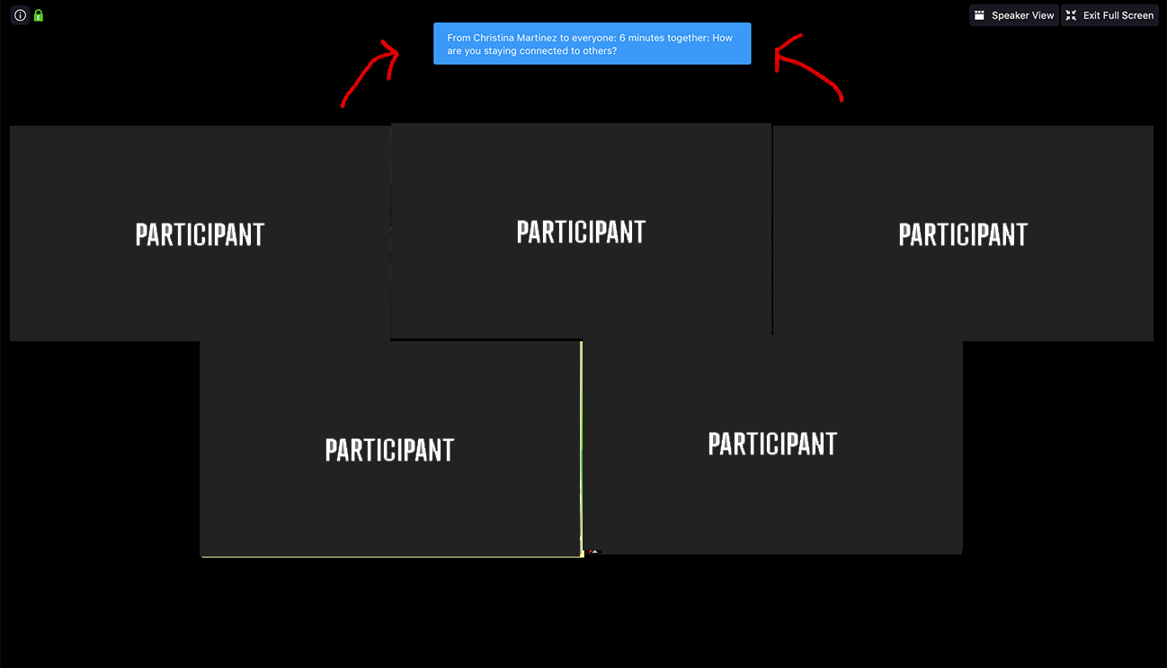
- Visit different breakout rooms: In the GIF below, you’ll also see me hopping into one of the breakout rooms. This is a great way to pop in and see that everything is going smoothly for your participants.
- Help out: If someone “asks for help”—in each breakout room participants will see a button on their control panel that says “ask for help”—you can also go directly into their room.
More Zoom Resources:
- Managing Video Breakout Rooms
- Participating in Breakout Rooms

HOW CAN I
(THE HOST) BROADCAST A MESSAGE TO BREAKOUT GROUPS?
____________
HOW DO I VISIT A BREAKOUT GROUP?

PART 3. Closing the Event

Closing Comments & Group Photos
- Ask everyone to share an answer to a question in the chat box synchronously (such as “How are you feeling?” or “What’s one word that reflects what you’re excited about today?”). Give everybody a chance to scroll through and read this before you end the meeting. Read some of your favorite sentiments aloud and allow the community to share some of their favorites, or give dedicated time for participants to read them in silence. (Thanks Bridget!)
- Take a screenshot of the gallery view, with everyone raising their cups of coffee

Ending the Meeting
- It can sometimes be awkward to end a Zoom call. Have everyone wave “bye” and give people some time to leave before ending the call.
- Reminder: When the host leaves the meeting, it will ask if you want to end the meeting for all!

HOSTING TROLL-FREE/PLAYFUL/INTERACTIVE VIRTUAL EVENTS WITH ZOOM by Alexandra Kutler is licensed under a Creative Commons Attribution 4.0 International License.
Based on a work at https://docs.google.com/document/d/1KLRrnm6g5YvD8QRSPwwNWq6NPk9FYvMpZPy_XEyOmMM/edit#.
Permissions beyond the scope of this license may be available at alexakutler.com.

